**Light to Letter Converter**

**in**

Electronics and Communication Engineering

Submitted by

**Piyush Rohit(23ECE1038)**

**Ameer(23ECE1039)**

**Sahil Kesarkar(22ECE1027)**

To

**Dr. Anirban Chatterjee**

Associate Professor at NIT Goa



Department of Electronics and Communication Engineering

National Institute of Technology Goa

INTRODUCTION:-

The Rapidly of evolving communication technologies, alternative and assistive methods of information transfer have gained significant importance. One such innovation is the light-to-letter converter, a system designed to interpret light signals and convert them into corresponding alphabetic characters.

This technology is particularly useful in optical communication, assistive devices for the differently-abled, and hands-free or silent communication systems. By using a light source—such as an LED, laser, or flashlight—to transmit coded signals, and a light sensor to receive them, the system can decode the pattern and display or output the corresponding letter.

The concept is based on the principle of detecting variations in light intensity or blinking patterns, which are then processed by a microcontroller or software algorithm. These patterns may follow predefined formats such as Morse code, binary, or custom signal mapping.

This project not only explores the fascinating interaction between light and digital decoding but also serves as a foundation for more advanced systems like optical keyboards, vision-based communication tools, and smart IoT devices.

**HARDWARE DESCRIPTION**

|  |  |  |  |
| --- | --- | --- | --- |
| **Sr.no** | **Components** | **Value** | **Quantity** |
| **1** | **Laser Transmitter Module** |  | **1** |
| **2** | **Laser Receiver Module** |  | **1** |
| **3** | **Arduino Microcontroller** |  | **2** |
| **4** | **Connecting Wires** |  |  |
| **5** | **Oled display** |  | **2** |
| **6** | **5 key keyboard module** |  | **1** |

**Component discription**

1. **Laser Transmitter Module:** The laser diode within the module is energized by an electrical current. This process leads to the emission of photons. The structure of the laser diode, including a resonant cavity with mirrors, causes these photons to stimulate the emission of more photons at the same wavelength and phase, resulting in a coherent and focused laser beam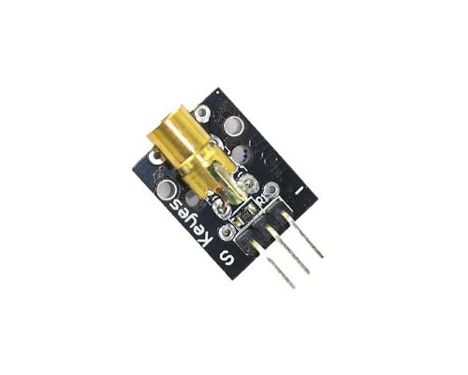 **2)Laser receiver Module:** A typical laser receiver module utilizes a photodetector, such as a photodiode or a phototransistor, which is sensitive to light at the wavelength of the incoming laser. When the laser beam strikes the photodetector, it generates a change in electrical current or voltage. This change is then processed by internal circuitry within the module to produce a usable output signal, often a digital signal (HIGH or LOW)

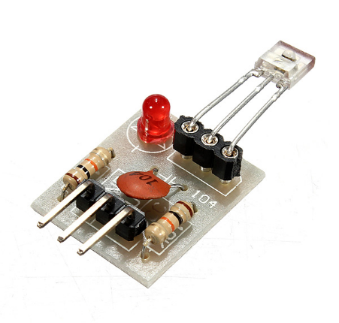

**3)Arduino Microcontroller:** This serves as the central processing unit for the decoder. It will read the signal from the laser receiver, process it to identify Morse code elements (dots and dashes), and eventually translate them into characters.

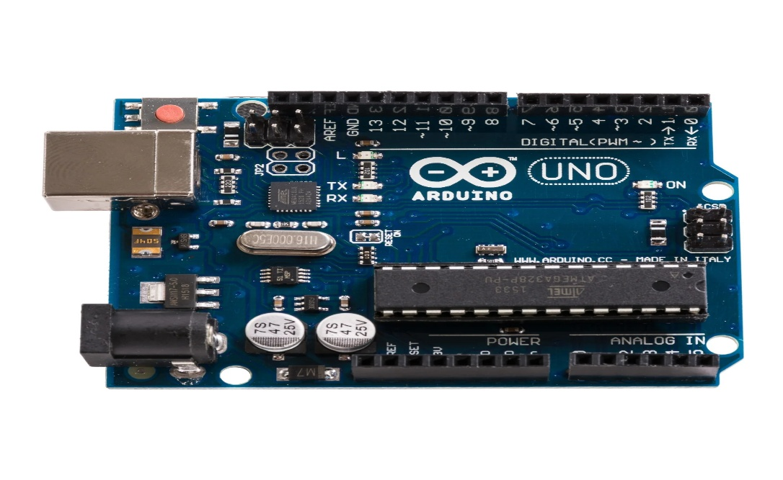

4) **Connecting Wires:** Used to establish electrical connections between the modules and the Arduino.

**5)Oled display:-**

An OLED display (Organic Light Emitting Diode display) is a type of flat-panel display technology made up of organic compounds that emit light when an electric current is applied. Unlike traditional LCDs (Liquid Crystal Displays), OLEDs do not require a backlight, as each pixel generates its own light. This allows for deeper blacks, higher contrast ratios, and thinner, more flexible screens.

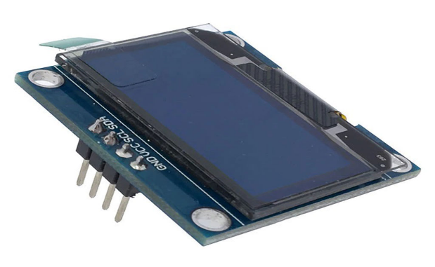

**6)5 key keyboard module:-**

A 5-key keyboard module is a small electronic component containing five individual push buttons arranged for directional and selection input, commonly used in microcontroller projects for user interaction.

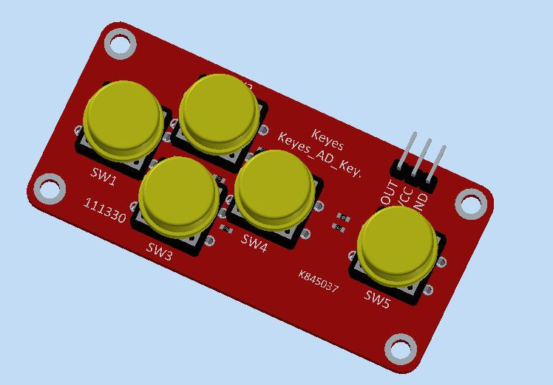

**Circuit diagram:-**

**1)Transmitter circuit:-**

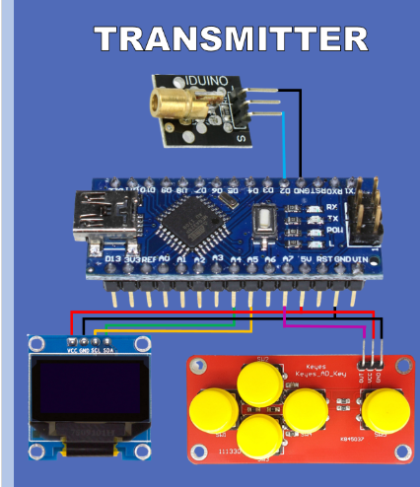

**Code:-**  **// Mario's Ideas**

**// Text input using OLED display an 5 Key Keyboard and encoding it to Morse Code**

**#include <SPI.h>**

**#include <Wire.h>**

**#include <Adafruit_GFX.h>**

**#include <Adafruit_SSD1306.h>**

**// Oled display size**

**#define SCREEN_WIDTH 128 // OLED display width, in pixels**

**#define SCREEN_HEIGHT 64 // OLED display height, in pixels**

**// Array holding all Morse code letter dot dash combinations**

**char MorseCode[26][6] = {**

**{'.','-','x','x','x','A'},**

**{'-','.','.','.','x','B'},**

**{'-','.','-','.','x','C'},**

**{'-','.','.','x','x','D'},**

**{'.','x','x','x','x','E'},**

**{'.','.','-','.','x','F'},**

**{'-','-','.','x','x','G'},**

**{'.','.','.','.','x','H'},**

**{'.','.','x','x','x','I'},**

**{'.','-','-','-','x','J'},**

**{'-','.','-','x','x','K'},**

**{'.','-','.','.','x','L'},**

**{'-','-','x','x','x','M'},**

**{'-','.','x','x','x','N'},**

**{'-','-','-','x','x','O'},**

**{'.','-','-','.','x','P'},**

**{'-','-','.','-','x','Q'},**

**{'.','-','.','x','x','R'},**

**{'.','.','.','x','x','S'},**

**{'-','x','x','x','x','T'},**

**{'.','.','-','x','x','U'},**

**{'.','-','-','x','x','W'},**

**{'.','.','.','-','x','V'},**

**{'.','-','-','.','x','X'},**

**{'-','.','-','-','x','Y'},**

**{'-','-','.','.','x','Z'},**

**//Potentiometer PIN A1**

**int Keyboard=A2;**

**// Variables capturing current and newly calculated position on the letter board (9x3 - 27 postions)**

**int New_X=0;**

**int Old_X=0;**

**int New_Y=0;**

**int Old_Y=0;**

**// Variable capturing output from Keyboard pin (Values 0 1023)**

**int Key_read=0;**

**int Prev_Key_read=1023;**

**boolean Key_pressed=false;**

**// String variable holding the text to transmit**

**String To_Transmit="";**

**//Unit length**

**int unit=300;**

**// Length of the text to transmit**

**int To_Transmit_Length=0;**

**// Declaration for an SSD1306 display connected to I2C (SDA, SCL pins)**

**#define OLED_RESET 4 // Reset pin # (or -1 if sharing Arduino reset pin)**

**Adafruit_SSD1306 display(SCREEN_WIDTH, SCREEN_HEIGHT, &Wire, OLED_RESET);**

**// Used for displaying Leter board**

**char Letters[3][9]={"ABCDEFGHI",**

**"JKLMNOPQR",**

**"STUVWXYZ_"};**

**// Play/Display Morse code representation of the letter**

**void Play_Letter (char Letter){**

**// searching in MorseCode array for the corresponding letter**

**if (Letter=='_') delay(5*unit); else {**

**for (int j=0; j<26; j++){**

**if (MorseCode[j][5]==Letter)**

**// if the right letter is detected run Play_Dot_Dash for . or -**

**for (int k=0; k<4;k++){**

**if (MorseCode[j][k]!='x') Play_Dot_Dash(MorseCode[j][k]);**

**}**

**}**

**delay(2*unit);**

**}**

**}**

**// Playing/Displaying . or -**

**void Play_Dot_Dash(char sign){**

**if (sign=='.'){**

**analogWrite(A3, 255);**

**delay(unit);**

**analogWrite(A3,0);**

**delay(unit);**

**}**

**if (sign=='-'){**

**analogWrite(A3, 255);**

**delay(3*unit);**

**analogWrite(A3, 0);**

**delay(unit);**

**}**

**}**

**void setup() {**

**Serial.begin(9600);**

**// SSD1306_SWITCHCAPVCC = generate display voltage from 3.3V internally**

**if(!display.begin(SSD1306_SWITCHCAPVCC, 0x3C)) { // Address 0x3D for 128x64**

**Serial.println(F("SSD1306 allocation failed"));**

**for(;;); // Don't proceed, loop forever**

**}**

**// Show initial display buffer contents on the screen --**

**// the library initializes this with an Adafruit splash screen.**

**display.display();**

**delay(2000); // Pause for 2 seconds**

**// Clear the buffer**

**display.clearDisplay();**

**display.display();**

**// Display filled in rect in the top section of the display when To_Transfer would be output**

**display.fillRect(0, 0, 128, 15, SSD1306_INVERSE);**

**display.drawRect(110, 2, 16, 12, SSD1306_BLACK);**

**display.setTextSize(1);**

**display.setTextColor(SSD1306_BLACK);**

**display.setCursor(113,4);**

**display.println("OK");**

**display.display();**

**// Display Letter Board 3 rows 9 character in each row**

**display.setTextSize(2);**

**display.setTextColor(SSD1306_WHITE);**

**for (int j=0; j<3;j++){**

**for (int i=0; i<9;i++){**

**display.setCursor(i*12+2*i+1,j*16+17);**

**display.println(Letters[j][i]);**

**delay(10);**

**display.display();**

**}**

**}**

**// Highlight character A by displaying Inverse rect at first position**

**display.fillRect(0, 16, 12, 16, SSD1306_INVERSE);**

**display.display();**

**}**

**void Highlight_letter(int X, int X_Old, int Y, int Y_Old){**

**// When position changes**

**// Draw the inverse rect in the Old_pos to deactivate the highlight in the old spot**

**// Draw the inverse rect to Highlite the new spot**

**// Displaying Inverse rect in a new position to highlight**

**display.fillRect(X*12+2*X, Y*16 +16, 12, 16, SSD1306_INVERSE);**

**// Displaying Inverse rect in the old positon to unhighlight**

**display.fillRect(X_Old*12+2*X_Old, Y_Old*16 +16, 12, 16, SSD1306_INVERSE);**

**display.display();**

**}**

**void loop() {**

**Key_read =analogRead(Keyboard);**

**if (Prev_Key_read>1000 and Key_read<1000){**

**Key_pressed=true;**

**if (Key_read<10 and Old_X>0) New_X=Old_X-1;**

**if (Key_read>500 and Key_read<515 and Old_X<9) New_X=Old_X+1;**

**if (Key_read>140 and Key_read<150 and Old_Y>-1) New_Y=Old_Y-1;**

**if (Key_read>325 and Key_read<335 and Old_Y<2 ) New_Y=Old_Y+1;**

**if (Key_read>735 and Key_read<745) {**

**if (New_Y!=-1){**

**To_Transmit=To_Transmit + Letters[New_Y][New_X];**

**To_Transmit_Length++;**

**display.setTextSize(1);**

**display.setCursor(3,1);**

**display.setTextColor(BLACK );**

**display.fillRect(0, 0, 100, 15, SSD1306_WHITE);**

**display.println(To_Transmit);**

**display.display();**

**}**

**else{**

**for (int i=0; i<To_Transmit.length();i++ ){**

**Play_Letter(To_Transmit.charAt(i));**

**}**

**}**

**}**

**if (New_Y==-1 and Old_Y==0){**

**display.fillRect(110, 2, 16, 12, SSD1306_INVERSE);**

**display.fillRect(Old_X*12+2*Old_X, Old_Y*16 +16, 12, 16, SSD1306_INVERSE);**

**}**

**if (New_Y==0 and Old_Y==-1){**

**display.fillRect(110, 2, 16, 12, SSD1306_INVERSE);**

**display.fillRect(New_X*12+2*New_X, New_Y*16 +16, 12, 16, SSD1306_INVERSE);**

**Prev_Key_read=Key_read;**

**Old_X=New_X;**

**Old_Y=New_Y;;**

**}**

**if ((Old_X!=New_X or Old_Y!=New_Y) and Old_Y!=-1 ){**

**if (New_Y!=-1 )Highlight_letter (New_X,Old_X,New_Y,Old_Y);**

**Old_X=New_X;**

**Old_Y=New_Y;**

**}**

**}**

**display.display();**

**Prev_Key_read=Key_read;**

**}**

**2) receiver circuit:-**

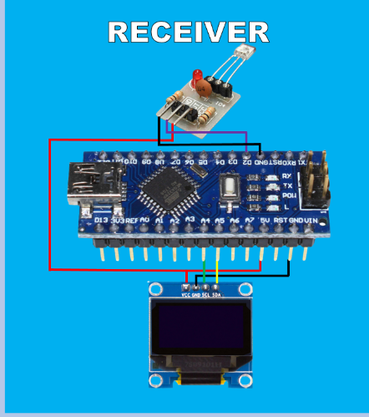

**Code:-**

**#include <Wire.h>**

**#include <Adafruit_GFX.h>**

**#include <Adafruit_SSD1306.h>**

**#include <avr/pgmspace.h>**

**const char alfabeth[] PROGMEM = {"ABCDEFGHIJKLMNOPQRSTUVWXYZ"};**

**const char morse_A[] PROGMEM = ".-";**

**const char morse_B[] PROGMEM = "-...";**

**const char morse_C[] PROGMEM = "-.-.";**

**const char morse_D[] PROGMEM = "-..";**

**const char morse_E[] PROGMEM = ".";**

**const char morse_F[] PROGMEM = "..-.";**

**const char morse_G[] PROGMEM = "--.";**

**const char morse_H[] PROGMEM = "....";**

**const char morse_I[] PROGMEM = "..";**

**const char morse_J[] PROGMEM = ".---";**

**const char morse_K[] PROGMEM = "-.-";**

**const char morse_L[] PROGMEM = ".-..";**

**const char morse_M[] PROGMEM = "--";**

**const char morse_N[] PROGMEM = "-.";**

**const char morse_O[] PROGMEM = "---";**

**const char morse_P[] PROGMEM = ".--.";**

**const char morse_Q[] PROGMEM = "--.-";**

**const char morse_R[] PROGMEM = ".-.";**

**const char morse_S[] PROGMEM = "...";**

**const char morse_T[] PROGMEM = "-";**

**const char morse_U[] PROGMEM = "..-";**

**const char morse_V[] PROGMEM = "...-";**

**const char morse_W[] PROGMEM = ".--";**

**const char morse_X[] PROGMEM = "-..-";**

**const char morse_Y[] PROGMEM = "-.--";**

**const char morse_Z[] PROGMEM = "--..";**

**const char *const morse_code[] PROGMEM = {morse_A, morse_B, morse_C, morse_D, morse_E, morse_F,**

**morse_G, morse_H, morse_I, morse_J, morse_K, morse_L,**

**morse_M, morse_N, morse_O, morse_P, morse_Q, morse_R,**

**morse_S, morse_T, morse_U, morse_V, morse_W, morse_X,**

**morse_Y, morse_Z};**

**char buffer[5];**

**#define OLED_RESET -1// Reset pin # (or -1 if sharing Arduino reset pin)**

**Adafruit_SSD1306 display(128, 64, &Wire, OLED_RESET);**

**String rcvd="";**

**String Message="";**

**char Matched_Letter;**

**int tol=10;**

**int unit=300;**

**#define LaserPin 2**

**int letter_index=-1;**

**unsigned long Lastrun=0;**

**unsigned long Start;**

**unsigned long End;**

**unsigned long Signal_Len=0;**

**unsigned long Pause_Len=0;**

**boolean TransferInProgress=false;**

**struct MorseCodeSignal{**

**char Letter;**

**String Signal;**

**};**

**void setup() {**

**Serial.begin(9600);**

**attachInterrupt(digitalPinToInterrupt(2), Signal_change,CHANGE);**

**// SSD1306_SWITCHCAPVCC = generate display voltage from 3.3V internally**

**if(!display.begin(SSD1306_SWITCHCAPVCC, 0x3C)) { // Address 0x3D for 128x64**

**Serial.println(F("SSD1306 allocation failed"));**

**for(;;); // Don't proceed, loop forever**

**}**

**display.display();**

**delay(2000); // Pause for 2 seconds**

**// Clear the buffer**

**display.clearDisplay();**

**display.fillRect(0,0,128,16,SSD1306_WHITE);**

**display.display();**

**}**

**void DrawSequence(int index, String instr){**

**int offset_X;**

**int offset_Y;**

**offset_X=9+int(index/6)*43;**

**offset_Y=17+(index-int(index/6)*6)*8;**

**display.fillRect(offset_X-2,offset_Y,2,6,SSD1306_WHITE);**

**for (int i=0; i<instr.length();i++ ){**

**if(instr.charAt(i)=='.'){**

**display.fillRect(offset_X,offset_Y,4,6,SSD1306_WHITE);**

**display.fillRect(offset_X,offset_Y+2,2,2,SSD1306_BLACK);**

**offset_X+=4;**

**}**

**if(instr.charAt(i)=='-'){**

**display.fillRect(offset_X,offset_Y,8,6,SSD1306_WHITE);**

**display.fillRect(offset_X,offset_Y+2,6,2,SSD1306_BLACK);**

**offset_X+=8;**

**}**

**}**

**display.display();**

**}**

**void DrawLetter(int index, char Letter){**

**int offset_X;**

**int offset_Y;**

**offset_X=int(index/6)*43;**

**offset_Y=16+(index-int(index/6)*6)*8;**

**display.setCursor(offset_X,offset_Y);**

**display.setTextSize(1);**

**display.setTextColor(SSD1306_WHITE);**

**display.println(Letter);**

**display.display();**

**}**

**void DrawMessage(String TextIn){**

**if (TextIn.length()>0){**

**display.fillRect(0,0,128,16,SSD1306_WHITE);**

**display.setCursor(3,1);**

**display.setTextSize(2);**

**display.setTextColor(SSD1306_BLACK);**

**display.println(TextIn);**

**display.display();**

**void Signal_change(){**

**if (millis()-Lastrun>10){**

**if(digitalRead(LaserPin)==1) {**

**Start=millis();**

**Pause_Len=Start-End;**

**if (TransferInProgress==false) {TransferInProgress=true;rcvd="";}**

**}**

**else {**

**End=millis();**

**Signal_Len=End-Start;**

**}**

**Lastrun=millis();**

**}**

**}**

**char Match_Letter(String input){**

**char Matched_letter;**

**String Sequence;**

**for (int i = 0; i < 26; i++) {**

**strcpy_P(buffer, (char *)pgm_read_word(&(morse_code[i]))); // Necessary casts and dereferencing, just copy.**

**Sequence=buffer;**

**if (Sequence==input) Matched_letter=pgm_read_byte_near(alfabeth+i);**

**}**

**return Matched_letter;**

**}**

**void loop() {**

**if (TransferInProgress){**

**if (Signal_Len>0){**

**if(Signal_Len>=(unit- unit/tol) and Signal_Len<=(unit+unit/tol)) {rcvd+='.';DrawSequence(letter_index,rcvd);}**

**if(Signal_Len>=(3*unit- unit/tol) and Signal_Len<=(3*unit+unit/tol)) {rcvd+='-';DrawSequence(letter_index,rcvd);};**

**// if(Signal_Len<(unit- unit*tolerance/100) or (Signal_Len>(unit+unit*tolerance/100)and Signal_Len<(3*unit- unit*tolerance/100)) or Signal_Len>(3*unit+unit*tolerance/100) )**

**Signal_Len=0;**

**}**

**if (Pause_Len>0){**

**if(Pause_Len>(unit- unit/tol) and Signal_Len<(unit+unit/tol)) {;}**

**if(Pause_Len>(3*unit- unit/tol) and Signal_Len<(3*unit+unit/tol)) {**

**Matched_Letter=Match_Letter(rcvd);**

**Message+=Matched_Letter;**

**DrawMessage(Message);**

**Serial.print(Matched_Letter);**

**DrawLetter(letter_index,Matched_Letter);**

**display.display();**

**Serial.println(rcvd);**

**rcvd="";**

**letter_index++;**

**Matched_Letter="";**

**}**

**Pause_Len=0;**

**}**

**if((millis()-End)>8*unit and TransferInProgress){**

**Matched_Letter=Match_Letter(rcvd);**

**Message+=Matched_Letter;**

**DrawMessage(Message);**

**display.display();**

**Serial.print(Matched_Letter);**

**DrawLetter(letter_index,Matched_Letter);**

**display.display();**

**Serial.println(rcvd);**

**rcvd="";**

**//letter_index=0;**

**TransferInProgress=false;**

**Message="";**

**Pause_Len=0;**

**WORKING PRINCIPLE:**

A **light-to-letter converter** typically refers to a device or system that detects light (usually a specific pattern or code) and converts it into a corresponding letter or character. This concept is often used in optical communication, assistive technologies (like devices for the visually or physically impaired), or optical character recognition (OCR) systems.

**Working Principle of a Light-to-Letter Converter**

**1. Light Detection**

* **Sensor Used:** A **photodiode**, **phototransistor**, or **LDR (light-dependent resistor)** is used to detect light.
* **Input Light Type:** The light may be constant, blinking, or modulated in a specific pattern (e.g., Morse code or barcode-style).

**2. Pattern Recognition or Decoding**

* The digitized signal is sent to a **microcontroller**, **DSP**, or **computer** that:
  + Detects the timing and/or intensity pattern of the light
  + Matches it against a predefined **codebook** (like Morse code, binary encoding, or ASCII)
  + Determines which **letter or character** the pattern corresponds to

**3. Letter Output**

* The system converts the detected pattern into a **letter or character** and:
  + Displays it on a screen
  + Sends it to another device
  + Speaks it via a speech synthesis module (for accessibility applications)

**Example Application: Morse Code Light Reader**

If someone blinks a flashlight in Morse code:

* The sensor detects short and long light pulses (dots and dashes).
* The microcontroller decodes the Morse code.
* The corresponding letter (e.g., ... → S) is displayed or spoken.

**Technologies Involved**

* **Light sensor** (LDR, photodiode)
* **Microcontroller** (Arduino, Raspberry Pi, etc.)
* **Signal processing** (via code or hardware)
* **Software algorithm** for decoding patterns
* **Display/Speech output**

**RESULT:-**

The light-to-letter converter is an innovative system that bridges optical signals and textual communication. By detecting and decoding light patterns—such as blinks, flashes, or encoded pulses—it effectively translates non-verbal, non-auditory input into readable letters or characters. This technology holds significant potential in assistive communication, optical data transmission, and educational tools.

Its working relies on the integration of light sensors, signal processing, and intelligent decoding algorithms,

often controlled by a microcontroller or computer. Depending on its application, the system can enhance

accessibility for individuals with disabilities, enable silent or remote communication, or even support automated recognition systems like OCR.

Overall, the light-to-letter converter showcases how light—a simple, universal medium—can be harnessed for meaningful and inclusive communication across various domains.

**Contribution:-**

**Ameer:-** connection of the circuit

**Piyush:-**coding

**Sahil:-**report making